Deep Learning & Advanced Models:
🔍 Deep Learning
- Deep Learning is subsets of artificial intelligence that uses artificial neural networks with many layers (hence "deep") to model complex relationships in data.
- Deep Learning is transforming the way machines understand, learn and interact with complex data
- Deep learning mimics neural networks of the human brain, it enables computers to autonomously uncover patterns and make informed decisions from vast amounts of unstructured data.
Machine Learning | Deep Learning
Apply statistical algorithms to learn the hidden patterns and relationships in the dataset. | Uses artificial neural network architecture to learn the hidden patterns and relationships in the dataset.
Can work on the smaller amount of dataset | Requires the larger volume of dataset compared to machine learning
Better for the low-label task. | Better for complex task like image processing, natural language processing, etc.
Takes less time to train the model. | Takes more time to train the model.
A model is created by relevant features which are manually extracted from images to detect an object in the image. | Relevant features are automatically extracted from images. It is an end-to-end learning process.
Less complex and easy to interpret the result. | More complex, it works like the black box interpretations of the result are not easy.
It can work on the CPU or requires less computing power as compared to deep learning. | It requires a high-performance computer with GPU.

Key Features:
- Neural Networks: Inspired by the human brain, these consist of layers of interconnected nodes (neurons).
- Automatic Feature Extraction: Unlike traditional ML, deep learning models can automatically learn features from raw data.
- Scalability: Performs well with large datasets and high computational power (e.g., GPUs).
- Applications:
  - Image and speech recognition
  - Natural language processing (NLP)
  - Autonomous vehicles
  - Medical diagnosis
  - Cybersecurity and Scientific Research
Popular Architectures:
- CNNs (Convolutional Neural Networks) – for image data
- RNNs (Recurrent Neural Networks) – for sequential data like time series or text
- Transformers – for NLP tasks (e.g., BERT, GPT)

🚀 Advanced Models
Advanced models refer to sophisticated machine learning or deep learning architectures that push the boundaries of performance, scalability, and interpretability.
Examples:
- Transfer Learning Models: Pre-trained models like ResNet, VGG, or BERT that can be fine-tuned for specific tasks.
- Generative Models: Such as GANs (Generative Adversarial Networks) and VAEs (Variational Autoencoders) for creating new data.
- Reinforcement Learning Models: Used in decision-making tasks like game playing or robotics.
- Large Language Models (LLMs): Like GPT-4 or PaLM, trained on massive text corpora for understanding and generating human-like language.
Cutting-Edge Techniques:
- Self-supervised learning
- Few-shot and zero-shot learning
- Multimodal models (e.g., combining text, image, and audio)
Concepts:
  - Convolutional Neural Networks (CNNs): For image processing (image classification, object detection - conceptual).
  - Recurrent Neural Networks (RNNs) & LSTMs: For sequence data (text, time series - conceptual).
  - Transfer Learning: Using pre-trained models.
  - Generative AI Basics: Brief introduction to concepts like GANs or VAEs (understanding the hype).
  - Prompt Engineering Basics: If interested in LLMs, understand how to effectively interact with them.
Convolutional Neural Networks (CNNs): For image processing (image classification, object detection - conceptual).
🧠 What Are CNNs?
CNNs are a type of deep learning model specifically designed for processing grid-like data, such as images. They are highly effective for tasks like:
- Image Classification: Identifying what object is in an image.
- Object Detection: Locating and identifying multiple objects within an image.
🧩 Key Components of CNNs
- Convolutional Layers:
  - Apply filters (kernels) to the input image to extract features like edges, textures, and shapes.
  - Each filter slides over the image and produces a feature map.
- Activation Function (ReLU):
  - Introduces non-linearity to help the network learn complex patterns.
- Pooling Layers (Max Pooling):
  - Reduce the spatial size of feature maps.
  - Helps in reducing computation and controlling overfitting.
- Fully Connected Layers:
  - After feature extraction, these layers perform classification based on the learned features.
- Output Layer:
  - For classification: outputs probabilities for each class.
  - For detection: outputs bounding boxes and class labels.
🖼️ Image Classification vs Object Detection
Feature | Image Classification | Object Detection
Goal | Identify the main object in an image | Identify and locate multiple objects
Output | Class label (e.g., "cat") | Bounding boxes + class labels
Example Models | VGG, ResNet, EfficientNet | YOLO, SSD, Faster R-CNN

🔍 Conceptual Flow
Image Classification:
- Input image → Convolution → Feature Maps
- Pooling → Reduced Feature Maps
- Fully Connected Layers → Class Probabilities
Object Detection:
- Input image → Convolution → Feature Maps
- Region Proposal or Grid-based Detection
- Bounding Boxes + Class Labels
Recurrent Neural Networks (RNNs) & LSTMs: For sequence data (text, time series - conceptual).
https://www.kaggle.com/code/moonglow22/rnn-and-lstm-tutorial-for-beginners
Recurrent Neural Networks (RNNs) and Long Short-Term Memory networks (LSTMs) conceptually, especially for sequence data like text and time series.
Recurrent Neural Networks (RNNs):- RNNs are designed to process sequential data, where the order of inputs matters—such as sentences, speech, or time-series signals.

Core Ideas:
- Memory of Past Inputs: RNNs maintain a hidden state that carries information from previous time steps.
- Looping Architecture: Unlike feed forward networks, RNNs have loops that allow information to persist across time.
- Sequential Prediction: Each output depends not just on the current input, but also on previous inputs.

Limitations:
- Vanishing Gradient Problem: As sequences grow longer, RNNs struggle to retain information from earlier steps.
- Short-Term Memory: They perform well on short sequences but fail to capture long-range dependencies.

Long Short-Term Memory Networks (LSTMs):- LSTMs are a specialized type of RNN designed to remember information over long periods.

Architecture:
LSTMs use gates to regulate the flow of information:
- Forget Gate: Decides what information to discard.
- Input Gate: Determines what new information to store.
- Output Gate: Controls what information to pass to the next step.

Advantages:
- Solves Vanishing Gradient Problem: Effective at learning long-term dependencies.
- Context-Aware: Ideal for tasks like translation, sentiment analysis, and time-series forecasting2.

Limitations:
- Complexity: More parameters than RNNs, making them slower to train.
- Sequential Nature: Harder to parallelize, which can slow down training.

Applications of RNNs & LSTMs
Domain | Example Use Case
Natural Language | Text generation, translation
Finance | Stock price prediction
Healthcare | Patient monitoring over time
Audio | Speech-to-text, music composition
IoT | Sensor data analysis

Transfer Learning: Using pre-trained models:-

Transfer learning is a powerful technique in deep learning where a model developed for one task is reused as the starting point for a model on a second task.
This is especially useful when you have limited data for the new task but want to leverage the knowledge from a model trained on a large dataset.

What Is Transfer Learning? Transfer learning involves:
- Using a pre-trained model (e.g., VGG16, ResNet, MobileNet) trained on a large dataset like ImageNet.
- Adapting it to a new, often smaller dataset by fine-tuning or feature extraction.
- it's beneficial for reducing training time and improving performance.
How to Use Pre-Trained Models:
Transfer learning involves a structured process to use existing knowledge from a pre-trained model for new tasks:
- Pre-trained Model: Start with a model already trained on a large dataset for a specific task. This pre-trained model has learned general features and patterns that are relevant across related tasks.
- Base Model: This pre-trained model, known as the base model, includes layers that have processed data to learn hierarchical representations, capturing low-level to complex features.
- Transfer Layers: Identify layers within the base model that hold generic information applicable to both the original and new tasks. These layers often near the top of the network capture broad, reusable features.
- Fine-tuning: Fine-tune these selected layers with data from the new task. This process helps retain the pre-trained knowledge while adjusting parameters to meet the specific requirements of the new task, improving accuracy and adaptability.
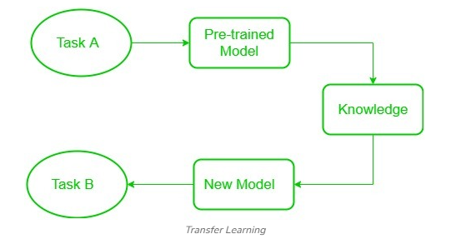
- Low-level features learned for task A should be beneficial for learning of model for task B.
Frozen Vs Trainable Layers in Transfer Learning: In Transfer Learning, two main components help in adapting models effectively:
- Frozen Layers: These layers from a pre-trained model remain unchanged during fine-tuning. They retain general features learned from the original task, extracting universal patterns from input data.
- Trainable Layers: These layers are adjusted during fine-tuning to learn task-specific features from the new dataset, allowing the model to meet the new task’s unique requirements.
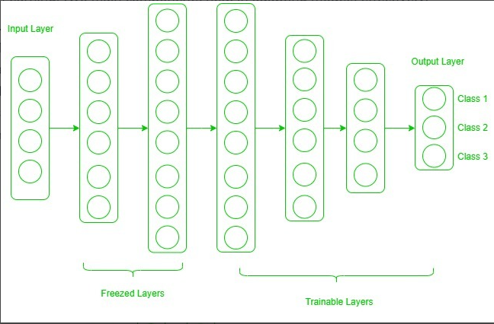

How to Decide Which Layers to Freeze or Train?
The extent to which you freeze or fine-tune layers depends on the similarity and size of your target dataset:
- Small, Similar Dataset: For smaller datasets that resemble the original dataset, you freeze most layers and only fine-tune the last one or two layers to prevent overfitting.
- Large, Similar Dataset: With large, similar datasets you can unfreeze more layers allowing the model to adapt while retaining learned features from the base model.
- Small, Different Dataset: For smaller, dissimilar datasets, fine-tuning layers closer to the input layer helps the model learn task-specific features from scratch.
- Large, Different Dataset: In this case, fine-tuning the entire model helps the model adapt to the new task while using the broad knowledge from the pre-trained model.

Generative AI Basics: Brief introduction to concepts like GANs or VAEs (understanding the hype):-
Generative AI is a fascinating field that focuses on creating new data—images, text, audio, or even video—that mimics the patterns of existing data. Two of the most prominent models in this space are GANs (Generative Adversarial Networks) and VAEs (Variational Autoencoders).
It is also called “generative AI or gen AI”
Businesses can use generative AI in many ways, like building chatbots, creating media, designing products, and coming up with new ideas.

What Are Generative Models?
Generative models learn the underlying distribution of data and can generate new samples that resemble the original dataset. They’re used in:
- Image synthesis (e.g., deepfakes)
- Text generation (e.g., ChatGPT)
- Music and art creation
- Drug discovery and molecule design

Evolution of Generative AI
- The Early Days: Rule-Based Systems
- Introduction of Machine Learning (1990s-2000s)
- The Rise of Deep Learning (2010s)
- Generative Adversarial Networks (2014)
- Large Language Models (LLMs) and Beyond (2020s)
- Multimodal Generative AI (Present)

Types of Generative AI Models
Generative AI is versatile, with different models designed for specific tasks. Here are some types:
- Text-to-Text: These models generate meaningful and coherent text based on input text. They are widely used for tasks like drafting emails, summarizing lengthy documents, translating languages, or even writing creative content. Tools like ChatGPT is brilliant at understanding context and producing human-like responses.
- Text-to-Image: This involves generating realistic images from descriptive text. For Example, tools like DALL-E 2 can create a custom digital image based on prompts such as "A peaceful beach with palm trees during a beautiful sunset," offering endless possibilities for designers, artists, and marketers.
- Image-to-Image: These models enhance or transform images based on input image . For example, they can convert a daytime photo into a night time scene, apply artistic filters, or refine low-resolution images into high-quality visuals.
- Image-to-Text: AI tools analyze and describe the content of images in text form. This technology is especially beneficial for accessibility, helping visually impaired individuals understand visual content through detailed captions.
- Speech-to-Text: This application converts spoken words into written text. It powers virtual assistants like Siri, transcription software, and automated subtitles, making it a vital tool for communication, accessibility, and documentation.
- Text-to-Audio: Generative AI can create music, sound effects, or audio narrations from textual prompts. This empowers creators to explore new soundscapes and compose unique auditory experiences tailored to specific themes or moods.
- Text-to-Video: These models allow users to generate video content by describing their ideas in text. For example, a marketer could input a vision for a promotional video, and the AI generates visuals and animations, streamlining content creation.
- Multimodal AI: These systems integrate multiple input and output formats, like text, images, and audio, into a unified interface. For instance, an educational platform could let students ask questions via text and receive answers as interactive visuals or audio explanations, enhancing learning experiences.
GANs: Generative Adversarial Networks: - (GAN) help machines to create new, realistic data by learning from existing examples.

Architecture of GAN: - GAN consist of two main models (neural networks) that work together to create realistic synthetic data
- Generator: The generator is a deep neural network that takes random noise as input to generate realistic data samples like images or text.
- Discriminator: Tries to distinguish between real and fake data. The discriminator acts as a binary classifier helps in distinguishing between real and generated data. It learns to improve its classification ability through training, refining its parameters to detect fake samples more accurately. When dealing with image data, the discriminator uses convolutional layers or other relevant architectures which help to extract features and enhance the model’s ability.
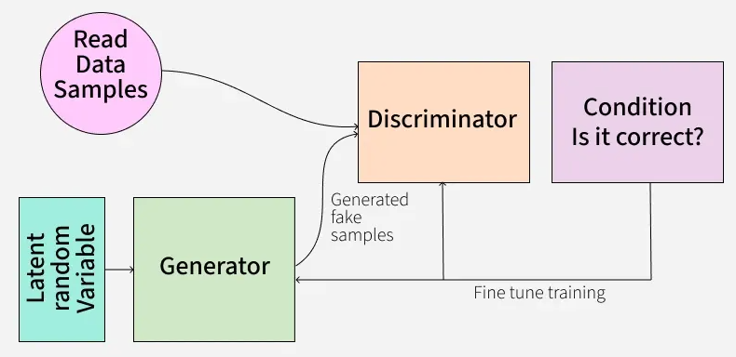
They play a game where the generator improves by fooling the discriminator, and the discriminator improves by catching the generator’s fakes.
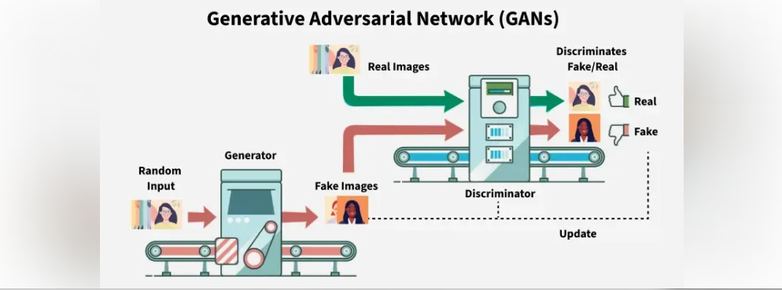

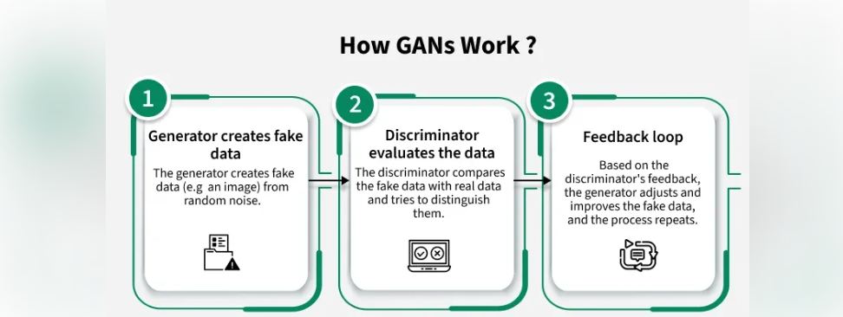

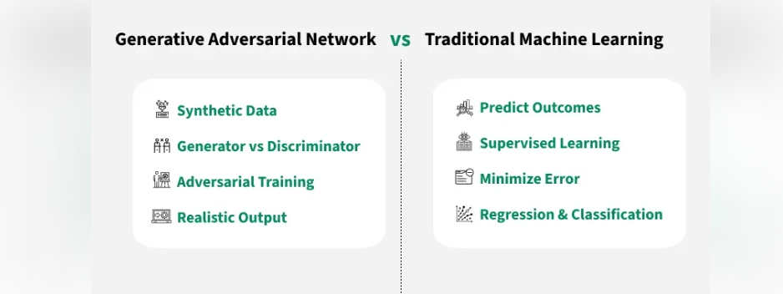
Types of GAN:-

Vanilla GAN:- Vanilla GAN is the simplest type of GAN. It consists of:
- A generator and a discriminator both are built using multi-layer perceptrons (MLPs).
- The model optimizes its mathematical formulation using stochastic gradient descent (SGD).
While foundational, Vanilla GAN can face problems like:
- Mode collapse: The generator produces limited types of outputs repeatedly.
- Unstable training: The generator and discriminator may not improve smoothly.

Conditional GAN (CGAN):- Conditional GAN (CGAN) adds an additional conditional parameter to guide the generation process. Instead of generating data randomly they allow the model to produce specific types of outputs.

Working of CGANs:
- A conditional variable (y) is fed into both the generator and the discriminator.
- This ensures that the generator creates data corresponding to the given condition (e.g generating images of specific objects).
- The discriminator also receives the labels to help distinguish between real and fake data.
Example: Instead of generating any random image, CGAN can generate a specific object like a dog or a cat based on the label.

Deep Convolutional GAN (DCGAN):- Deep Convolutional GAN (DCGAN) are among the most popular types of GANs used for image generation.
They are important because they:
- Uses Convolutional Neural Networks (CNNs) instead of simple multi-layer perceptrons (MLPs).
- Max pooling layers are replaced with convolutional stride helps in making the model more efficient.
- Fully connected layers are removed, which allows for better spatial understanding of images.
DCGANs are successful because they generate high-quality, realistic images.

Laplacian Pyramid GAN (LAPGAN)
Laplacian Pyramid GAN (LAPGAN) is designed to generate ultra-high-quality images by using a multi-resolution approach.
Working of LAPGAN:
- Uses multiple generator-discriminator pairs at different levels of the Laplacian pyramid.
- Images are first down sampled at each layer of the pyramid and upscaled again using Conditional GAN (CGAN).
- This process allows the image to gradually refine details and helps in reducing noise and improving clarity.
Due to its ability to generate highly detailed images, LAPGAN is considered a superior approach for photorealistic image generation.

Super Resolution GAN (SRGAN)
Super-Resolution GAN (SRGAN) is designed to increase the resolution of low-quality images while preserving details.
Working of SRGAN:
- Uses a deep neural network combined with an adversarial loss function.
- Enhances low-resolution images by adding finer details helps in making them appear sharper and more realistic.
- Helps to reduce common image upscaling errors such as blurriness and pixelation.

Applications:
- Creating realistic images and videos
- Style transfer
- Super-resolution
- Data augmentation
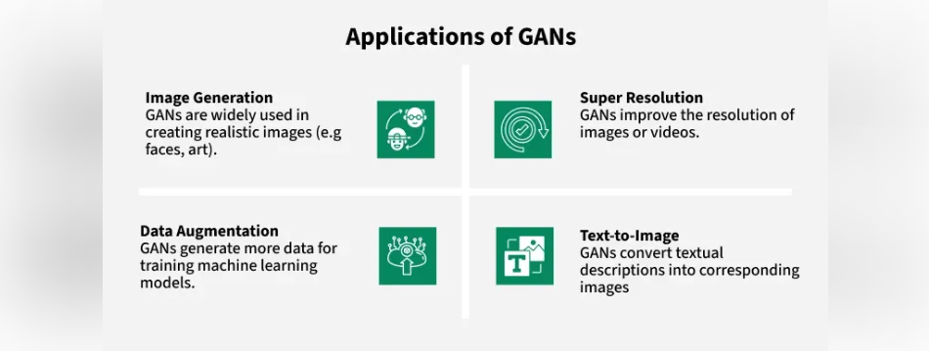

Implementing a Generative Adversarial Network (GAN) in Python typically involves using deep learning frameworks like TensorFlow or PyTorch. The core components of a GAN are a Generator and a Discriminator network, trained in an adversarial manner.

Advantages of GAN:

Synthetic Data Generation, High-Quality Results, Unsupervised Learning, Versatility

VAEs: Variational Autoencoders
Concept: Variational Autoencoders (VAEs) are type of generative model in machine learning that create new data similar to the input they are trained on. They not only compress and reconstruct data like traditional autoencoders but also learn a continuous probabilistic representation of the underlying features. This unique approach helps VAEs to generate new, realistic data samples that closely resemble the original input.
VAE is a special kind of autoencoder that can generate new data instead of just compressing and reconstructing it.

It has three main parts:

1. Encoder (Understanding the Input)
The encoder takes input data like images or text and learns its key features. Instead of outputting one fixed value, it produces two vectors for each feature:
Mean (μ): A central value representing the data.
Standard Deviation (σ): It is a measure of how much the values can vary.
These two values define a range of possibilities instead of a single number.

2. Latent Space (Adding Some Randomness)
Instead of encoding the input as one fixed point it pick a random point within the range given by the mean and standard deviation. This randomness lets the model create slightly different versions of data which is useful for generating new, realistic samples.

3. Decoder (Reconstructing or Creating New Data)
The decoder takes the random sample from the latent space and tries to reconstruct the original input. Since the encoder gives a range, the decoder can produce new data that is similar but not identical to what it has seen.
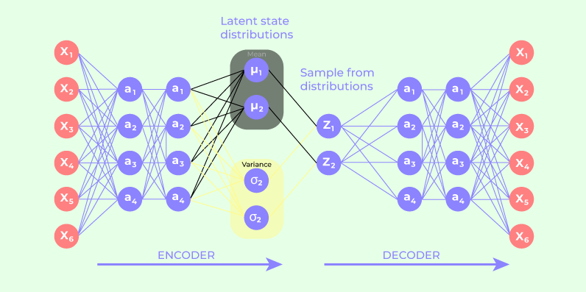
Applications:
- Image reconstruction
- Anomaly detection
- Music and molecule generation

Key Differences: GANs vs. VAEs
Feature |  | GANs | VAEs
Output Quality | Very realistic |  | Often blurry or smooth
Training Stability | Difficult to train |  | More stable
Latent Space | No explicit latent space |  | Structured latent space
Use Case | Image synthesis, deepfakes |  | Reconstruction, anomaly detection

Benefits of Generative AI:- Generative AI offers innovative tools that enhance creativity, efficiency, and personalization across various fields.

Limitations of Generative AI:- Data Dependence , Limited Control Over Outputs, High Computational Requirements, Ethical and Legal Concerns

Prompt Engineering Basics: If interested in LLMs, understand how to effectively interact with them.
If you're diving into the world of Large Language Models (LLMs), understanding prompt engineering is essential. It's the art and science of crafting inputs that guide models like ChatGPT, Claude, or Gemini to produce accurate, useful, and creative outputs.
What is Prompt?:- Prompts are short pieces of text that are used to provide context and guidance to machine learning models. When talking about the specific text AI tasks, also called NLP tasks, these prompts are useful in generating relevant outputs which are as close to the expected output itself.
Breakdown of the basics of prompt engineering and how to interact effectively with LLMs:
What Is Prompt Engineering?:- Prompt engineering is the process of designing and refining the text you input into an LLM to get the best possible result. It’s not just about asking questions—it’s about how you ask them.
Prompt engineering is the process of creating effective prompts that enable AI models to generate responses based on given inputs. Prompt engineering essentially means writing prompts intelligently for text-based Artificial Intelligence tasks, more specifically, Natural Language Processing (NLP) tasks.
Core Components of a Good Prompt:-
Component | Description | Example
Instruction | What you want the model to do | “Summarize the following article in two sentences.”
Context | Background info to guide the model | “This is for a high school student.”
Data | The content the model should act on | “Article: Climate change is accelerating…”
Format | Desired output style | “Respond in bullet points.”
Prompt Engineering Tips and How Prompt Engineering Works?
- Be Specific: Instead of “Describe this product,” say “Write a two-sentence formal description emphasizing durability.”
- Use Examples: Few-shot prompting (giving examples) helps the model learn the pattern.
- Control Hallucinations: Add instructions like “If unsure, respond with ‘I don’t know.’”
- Mind Token Limits: Keep prompts concise but informative—LLMs have memory limits.
- Leverage System Messages: These set the tone or persona of the model (e.g., “You are a helpful assistant…”).
- Crafting the Prompt: You design a prompt that specifies what you want the LLM to do.
- Understanding the LLM: Different prompts work better with different LLMs. Some techniques involve giving the LLM minimal instructions (zero-shot prompting), while others provide more context or examples (few-shot prompting).
- Refining the Prompt: It's often a trial-and-error process. You might need to tweak the prompt based on the LLM's output to get the kind of response you're looking for.
Foundational Techniques
- Information Retrieval: This entails the creation of prompts so that the LLM can get its knowledge base and give out what is relevant.
- Context Amplification: Give supplementary context to the prompt in order to direct the understanding and attention of the LLM to its output.
- Summarization: Induce the LLM to generalize or write summaries about complex themes.
- Reframing: Rephrase your reminder to the LLM to consider a specific style or format for the output.
- Iterative Prompting: Break down the complex tasks into smaller parts and then instruct the LLM sequentially in how to achieve the end result.
Advanced Techniques
- Least to Most Prompting: First, begin with prompts of general nature and then add facts to drive the LLM to make a highly specialized solution for intricate problems.
- Chain-of-Thought (CoT) Prompting: Require the LLM to show the steps of its reasoning as well as the answer, leading to enlightenments for our understanding of its thinking.
- Self-Ask Prompting: This thus entails chaining-of-thought (CoT) prompting, which involved the LLM being prompted to ask itself clarifying questions to get to a solution.
- Meta-Prompting: This experimental method investigates designing a single, common prompt that can be used for diverse tasks by way of additional instructions.

Advantages and Disadvantages of Prompt Engineering

Advantages
- Improved accuracy: A relevant prompt, means better work by the AI model which in turn only means a refined response simulated for the situation with precision. It can also be considered very useful especially talking about the niche domains like healthcare.
- Enhanced user experience: A better response only means a satisfied user who can easily get a response relevant to their problem without much of a hassle.
- Cost-effective: The number of rounds needed to achieve a single accurate and satisfactory response reduces with one specific and neatly engineered prompt.

Disadvantages
- Difficulty in determining specificity: Determining the right balance between specificity and generality can be challenging, as a prompt that is too specific may limit the range of responses generated, while a prompt that is too general may produce irrelevant responses.

Some of the key areas where prompt engineering can actually help make great progress:
- AI and NLP: As AI and NLP technologies advance, one expects to see significant improvements in the accuracy and effectiveness of prompts. With more sophisticated algorithms and machine learning models, prompts will advance and be more particular to the specific use cases.
- Integration with Other Technologies: Prompt engineering is likely to become increasingly integrated with other technologies, such as virtual assistants, chatbots, and voice-enabled devices. This will enable users to interact with technology more seamlessly and effectively, improving the overall user experience.
- Increased Automation and Efficiency: We can also expect to see increased automation and efficiency in the process along with more advanced prompts, hence, streamlining the development of prompts, therefore improving outputs.
Example:-

Best “Microsoft copilot” Prompts

Prompt Engineering: A Practical Example – Real Python

Example:-

Prompts: To Write an Essay on the Specified Title

Prompts: ModuleNotFoundError: No module named 'openai'

Output:

